Executive Summary
Monthly Consumer-Led Commercial Performance – December 2024
1. Headline Performance
December closed at £218.5K NSV (+2.9% MoM) driven primarily by +8.9% volume growth, while ASP declined -5.5% MoM to £58.57. This indicates that recent growth is volume-led rather than price-led, suggesting value dilution within the portfolio. Promotional intensity remained elevated at 30% of NSV (-0.3ppt MoM), reinforcing the likelihood that growth is being supported by pricing mechanics rather than premiumisation.
2. Growth Quality Assessment
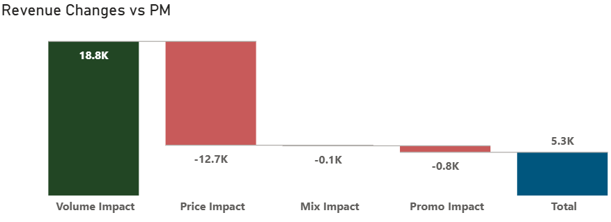
Revenue bridge analysis shows:
- Volume impact: +£18.8K
- Price impact: -£12.7K
- Promo impact: -£0.8K
While topline growth is positive, the magnitude of price erosion materially offsets volume gains. Growth in December is operationally strong but commercially diluted due to ASP compression. This dynamic reduces margin resilience and raises sustainability concerns if pricing discipline is not restored.
3. Consumer Segment Dynamics
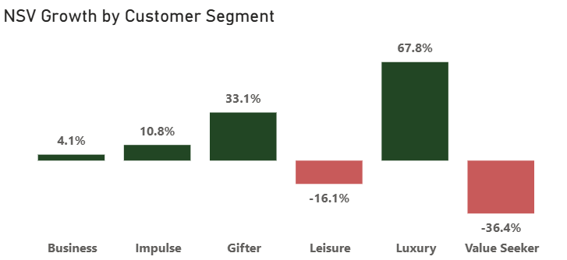
Performance varied materially across segments:
- Luxury: +67.8% NSV growth
- Gifter: +33.1%
- Impulse: +10.8%
- Business: +4.1%
- Value Seeker: -36.4%
- Leisure: -16.1%
Growth is being driven by premium-oriented segments (Luxury, Gifter), which partially offsets ASP decline. However, the volatility in Value Seeker suggests weakening demand elasticity in price-sensitive cohorts. Portfolio mix is therefore improving structurally, but promotional depth is masking ASP recovery.
4. Retailer Performance & Commercial Prioritisation
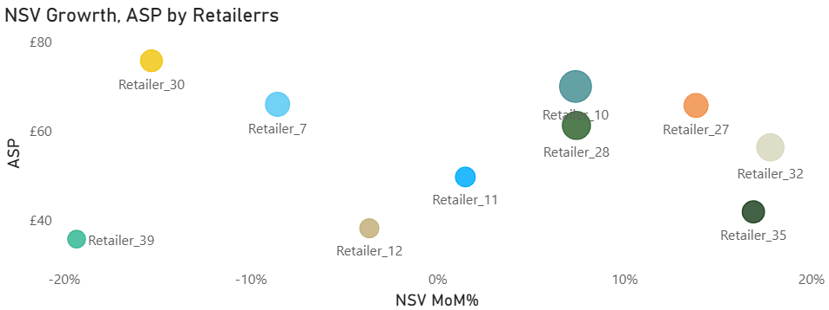
Retailer analysis highlights three strategic groups:
Protect & Scale
Retailer_10 – Strong NSV growth with maintained ASP
Retailer_30 – Premium positioning with stable value mix
Growth with Risk
Retailer_27 – Volume growth supported by price softness
Underperforming
Retailer_39 – Declining NSV and ASP deterioration
Immediate commercial focus should be placed on:
- Protecting premium retailers
- Reducing discount reliance in growth retailers
- Activating recovery plans for declining accounts

5. Recent Momentum (Nov–Dec Focus)
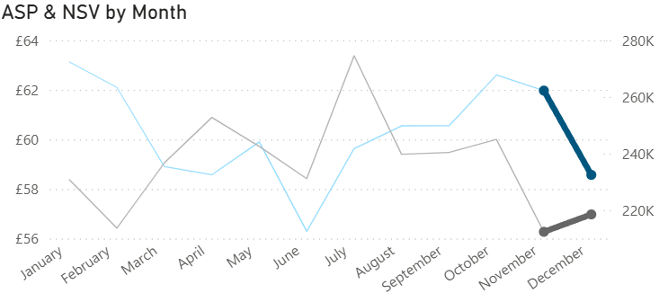
Highlight analysis of the last two months shows NSV acceleration from November into December.
However, ASP has not fully recovered to mid-year levels.
This suggests:
- Demand recovery is real
- Pricing power remains under pressure
If promotional intensity continues at current levels, ASP recovery may stall in Q1 2025.

Strategic Outlook
December performance demonstrates positive demand elasticity and strong premium-segment engagement.
However, continued ASP compression introduces risk to margin stability.
Commercial priority should shift toward:
- Reducing dependency on price-led activation
- Protecting premium mix gains
- Restoring ASP through controlled promotional depth

Closing Statement (Strong Portfolio Finish)
While topline momentum is encouraging, sustainable growth will depend on rebalancing volume expansion with pricing discipline.
The next quarter should focus on transitioning from promotional recovery to structural value growth.

